MAE 5316 – Advanced Mechatronics

Spring 2026 – Project # 2. Display and Touchscreen

Control of Servo and Stepper Motors

Description:
The project consists on building a circuit with the Arduino Pro Mini to control a stepper motor and a RC servo motor using an LCD display / touchscreen as user interface.
A TFT touch screen will be used to enter a position command in degrees that the motors will rotate. This will be an integer between 0 and 360 for the stepper, and 0 to 90 for the RC servo. A rotation command will be prompted on the LCD display, and the number entered should be echoed at the LCD.
- On start, prompt the user to select which motor to drive (servo or stepper)
- Direction should be prompted as CW/CCW
- After holding position for “n” seconds, the motor returns to the zero position.
- Program returns to the start prompt
Parts List:
- Solderless breadboard
- Arduino microcontroller + FTDI USB programming interface + STM32 Nucleo board
- TFT display touch screen – choose within several brands that are available.
- Stepper motor + Stepper motor driver
- RC servo motor
- Power supply with sufficient capacity to drive both motors. The USB port on your PC or laptop does NOT provide enough current to drive the motors. You can damage your USB port if you try to drive your motors from the USB port, or the USB port may just disconnect (if it has an internal protection circuit).
Grading Scale:
- Works perfect in Arduino:
  - Capacitive touchscreen: 82/100, resistive touchscreen: 90/100
- Works perfect in AVR Studio:
  - Capacitive touchscreen: 95/100, resistive touchscreen: 100/100

Notes: The recommended sequence to build this project is:
- Verify that your display works properly (display "Hello World” of some kind)
- Develop a "Read Touch Screen" routine that reads the touch screen coordinates when you touch the screen with a pen’s tip
- Develop the stepper motor driver routine.
- Develop RC servo program – You need to use the PWM registers in Atmel. It helps to test the generated pulse width using an oscilloscope (Rm 322, Olin Engineering)
- After checking each subsystem separately, integrate all components into a single program.
Arduino pin equivalence for parallel ports:
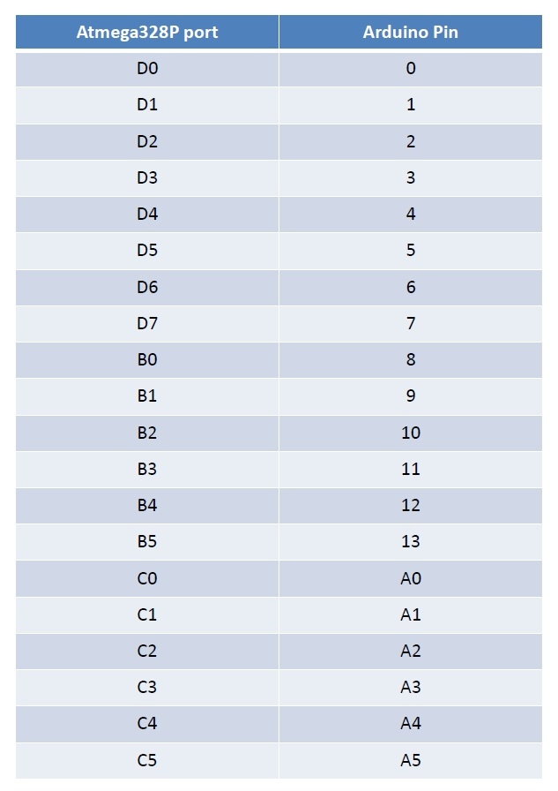
- Atmega328P (pro mini IC) datasheet:
  - §13 for I/O ports
  - §17 for PWM
  - §23 for ADC
- TFT Touchscreen: Resistive touchscreen: https://www.adafruit.com/product/1774?srsltid=AfmBOopKBDyBl7NwNwNlL7atzBM4SGT6qLul98nl5hMEuekmHfzaOP5O
- Capacitive/Resistive touchscreen: https://www.adafruit.com/product/1770 https://learn.adafruit.com/adafruit-2-8-and-3-2-color-tft-touchscreen-breakout-v2/capacitive-touchscreen
- Driver Stepper Motor - A4988 Datasheet
- USART C library - To help with debugging.
This requires pins RXI and TXO free and works with the FTDI USB board.
- 2 Macros that are used to change bit MASK of the register VAR
#define sbi(var, mask) ((var) |= (uint8_t)(1 << mask)) // Makes High
#define cbi(var, mask) ((var) &= (uint8_t)~(1 << mask)) // Makes Low
- Atmel Studio standard libraries reference:
http://www.nongnu.org/avr-libc/user-manual/modules.html
For this project, you will need:
<avr/io.h> - I/O configuration
<math.h> THEN <util/delay.h> - delay
<stdlib.h> - data type conversion
- Tips for ADC:
Here are the registers you will need to use:
  - I/O analog pins registers
  - ADMUX, ADCSRA, ADCH
- Tips for PWM:
Here are the registers you will need to use:
  - I/O PWM pin registers
  - TCCR2A / TCCR2B, OCR2A, OCR2B, ASSR

